**Sampling Methodology**

* Bag of little bootstraps
  + Replacement and non-replacement
  + Replacement -> Partition, without replacement -> combination
* Bootstrap with replacement
* Small source distribution
  + Forced to have replacement?

**Effect of Replacement vs No Replacement in Bootstrap Sampling**

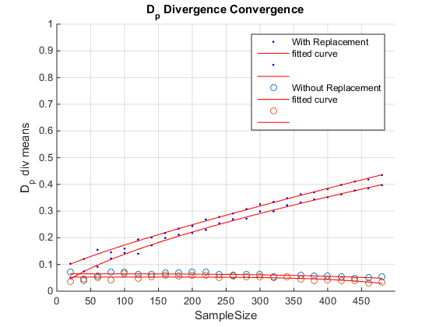

Test case: 2-d Gaussian with same variance, differing means.

100 trials, 500 sample source data

* Sampling with replacement leads to issues in the asymptotic convergence
* Without replacement led to faster convergence
* 95% Confidence intervals for no replacement case were also tighter (~.005 vs ~.03)

**Same plot as above, Displaying Difference in Boxplot**

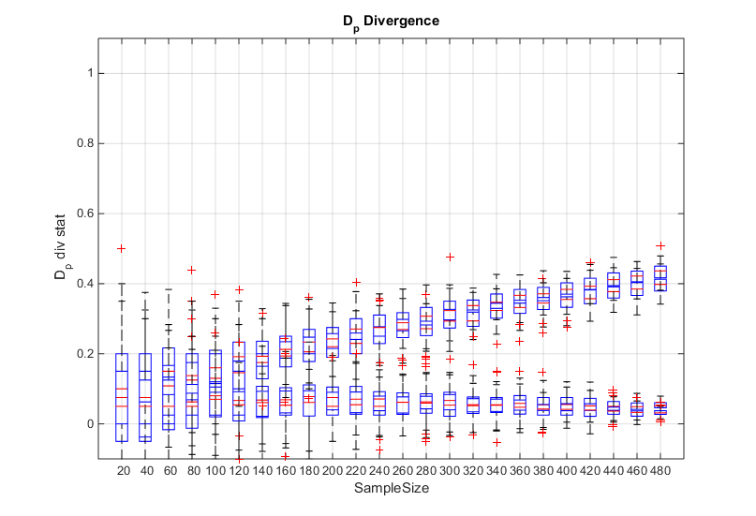

**Rate of convergence**

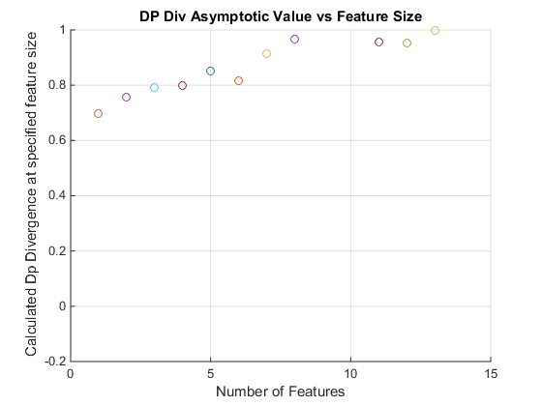

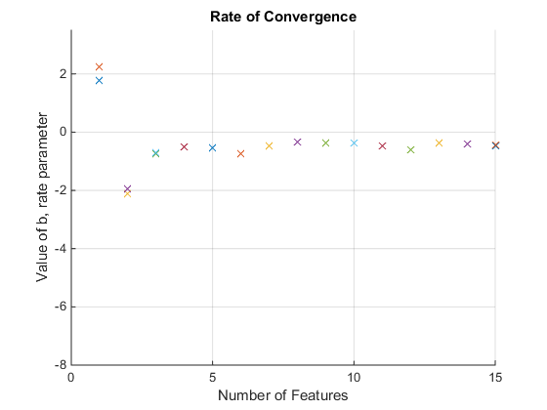

Rate of convergence versus number of features

Each feature had 500 data points

mean(Data1) = [ 0.1138 1.5589 1.3566 1.3255 0.0736 0.2890 1.4353 0.6434 1.6433 0.9569 0.9769 0.1133 0.3213 1.7023 0.3556]

mean(Data2) = [2.2020 1.0882 2.1548 1.3294 2.7981 0.4677 2.8188 1.9440 -0.0183 1.0234 2.9059 0.2699 2.1975 2.1865 1.8280]

**Consider for different distribution types**